# Task Submission: Python Data Analysis using Pandas
## 1. Project Objective
The objective of this task is to demonstrate data analysis skills using the Pandas library in Python. The task includes loading a CSV dataset, inspecting the data, cleaning missing values, applying filtering and grouping operations, and generating meaningful insights from the data.

## 2. Dataset Description
For this task, a structured CSV dataset named employees.csv was used.
The dataset contains employee information including:
Name (Categorical)
Department (Categorical)
Age (Numerical)
Salary (Numerical)
This is a synthetic dataset created for demonstration purposes. It simulates real-world employee salary data and allows implementation of data cleaning and aggregation techniques.
## 3. Steps Performed
✅ Step 1: Loading the Dataset
The dataset was loaded using:
Python
df = pd.read_csv("employees.csv")
This converts the CSV file into a Pandas DataFrame for analysis.
✅ Step 2: Inspecting the Dataset
The dataset was inspected using:
df.head() → Displays first 5 rows
df.info() → Displays column details and data types
df.describe() → Shows statistical summary
This helps in understanding the structure and identifying missing values.
✅ Step 3: Cleaning Missing Data
The dataset contained missing values in:
Age column
Salary column
To handle missing data:

Salary missing values were replaced with the mean salary
Age missing values were replaced with the median age
Python
df["Salary"].fillna(df["Salary"].mean(), inplace=True)
df["Age"].fillna(df["Age"].median(), inplace=True)
Mean was used for salary because it represents average income, while median was used for age to avoid influence of outliers.
✅ Step 4: Filtering Data
Employees earning more than 60,000 were filtered using:
Python
df[df["Salary"] > 60000]
This helps identify high-income employees.
✅ Step 5: Grouping and Aggregation
The average salary per department was calculated using:
Python
df.groupby("Department")["Salary"].mean()
This groups employees by department and calculates average salary.
## 4. Results and Observations
After performing the analysis:
IT department has the highest average salary.
Finance department also shows high salary distribution.
HR department has comparatively lower average salary.
Missing values were successfully handled.
Salary distribution differs across departments.
## 5. Insights Summary (Simple Explanation)
Based on the analysis:
The IT department pays the highest average salary.
Finance employees also earn high salaries.
HR department salaries are relatively lower.
Replacing missing values improved dataset reliability.
Data analysis helps understand department-wise salary trends.
## 6. Screenshots
Dataset preview (df.head output)
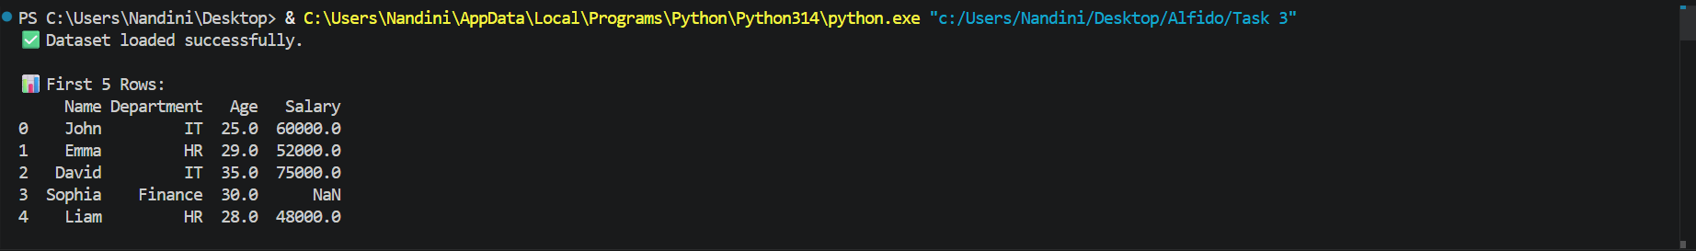
Dataset info (df.info output)
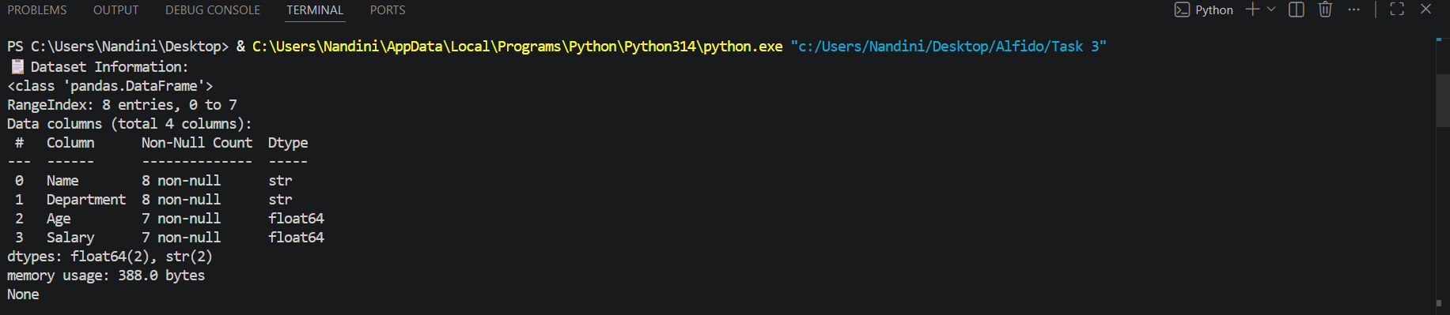
Filtered results
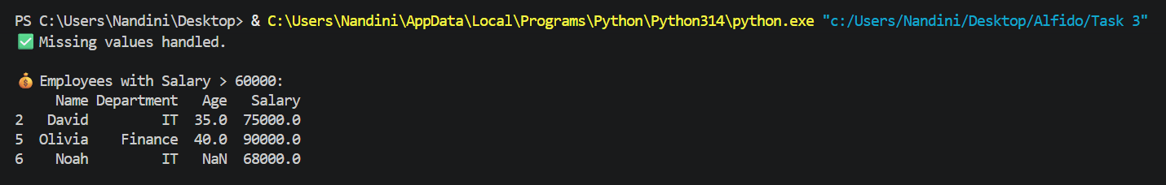
Grouped average salary output
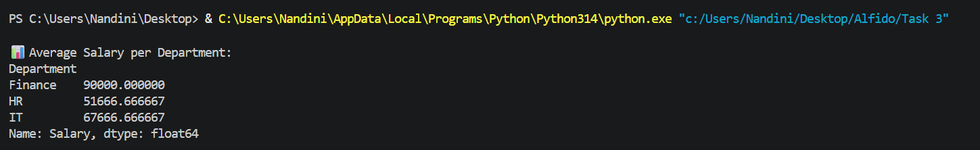
Final insight output
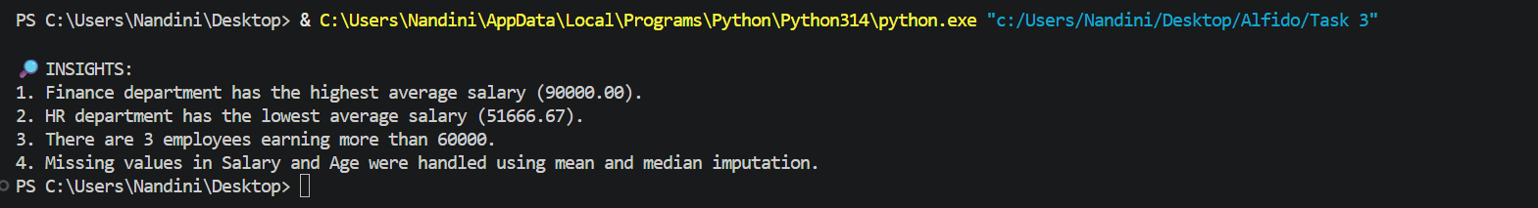
## 7. Github Repository Link
https://github.com/nandinivetcha-hub/python-data-analysis-task3.git

